ShopEZ
E-Commerce Platform

Backend Technical Documentation

Microservices Architecture with ASP.NET Core & Docker

Name | Vishnu Nair
Trainer Name | Narasimha Rao
Batch | B3 .Net FSD
Date of Creation | 15/5/2026
Tech Stack | Backend Documentation

1. Introduction
ShopEZ is a full-stack e-commerce platform built as part of the M.Tech curriculum at G H Raisoni College of Engineering. The backend is architected as a distributed microservices system powered by ASP.NET Core 8, enabling modularity, independent scalability, and clean separation of concerns across its four core domains: Users, Products, Orders, and Cart.
Each microservice owns its dedicated SQL Server database, communicates through well-defined REST APIs, and is containerized using Docker. An Ocelot-based API Gateway serves as the single entry point, routing all frontend requests to the appropriate downstream service.

1.1 Objectives
- Design a loosely coupled, independently deployable microservices backend
- Implement clean architecture with Controllers, Services, Repositories, and DTOs in each microservice
- Use Entity Framework Core (EF Core) for ORM in User, Order, and Cart services
- Use Dapper (micro-ORM) in the Product Service for high-performance raw SQL queries
- Expose a unified API surface via Ocelot API Gateway
- Orchestrate all services using Docker Compose for one-command deployment
- Achieve comprehensive unit test coverage using xUnit and Moq

1.2 Scope
This document covers the complete backend implementation of ShopEZ — architecture decisions, API design, database schema, system design diagrams, testing strategy, deployment guide, and future roadmap. It does not cover the Angular frontend; refer to the Frontend Documentation for that.

2. Problem Statement — Issues in Existing Systems
Traditional monolithic e-commerce backends face a range of structural limitations that make them difficult to scale, maintain, and evolve:

2.1 Monolithic Architecture Problems
- All business domains (users, products, orders, cart) are tightly coupled inside a single deployable unit
- A bug or failure in one module (e.g., Cart) can bring down the entire application
- Scaling requires replicating the entire monolith, even if only one domain experiences high load
- Deploying a small change requires redeploying and retesting the whole system
- Technology lock-in: the entire stack must use the same language, framework, and ORM

2.2 Database Coupling
- Single shared database creates schema coupling — changing one table risks breaking unrelated modules
- Concurrent writes across all domains contend on the same connection pool, creating bottlenecks
- No domain isolation: a bad migration in the products table can corrupt user data

2.3 Deployment & Operations Issues
- No container-based deployment makes environment consistency (dev vs prod) difficult
- Manual setup of dependencies across environments leads to 'works on my machine' failures
- No clear API gateway layer — frontend developers must hardcode individual service URLs

2.4 Testing Gaps
- Tightly coupled code makes unit testing nearly impossible without spinning up the entire application
- Absence of mock-based testing leads to slow, fragile integration tests that depend on live database connections

3. Proposed System
ShopEZ resolves these problems through a microservices architecture with clear domain boundaries, independent databases, containerized deployment, and a dedicated API gateway layer.

3.1 Microservices Decomposition
The system is decomposed into four domain services, each with full independence:

Service | Responsibility | Port | ORM | Database
User Service | Registration, Login, Auth | 8081 | EF Core | ShopEZ_Users
Product Service | CRUD, Search, Pagination | 8082 | Dapper | ShopEZ_Products
Order Service | Order creation, history | 8083 | EF Core | ShopEZ_Orders
Cart Service | Add, remove, clear cart | 8084 | EF Core | ShopEZ_Cart
API Gateway | Route forwarding via Ocelot | 8080 | — | —

3.2 Technology Choices
- ASP.NET Core 8: Modern, cross-platform, high-performance web API framework
- EF Core: Code-first ORM with automatic migrations for User, Order, and Cart services
- Dapper: Lightweight micro-ORM for Product Service — gives explicit SQL control with better performance for complex queries
- Ocelot: .NET-native API Gateway that handles routing, load balancing, and can be extended for auth
- Docker Compose: Declarative multi-container orchestration for one-command spin-up
- SQL Server 2022: Production-grade relational database with full ACID compliance
- xUnit + Moq: Modern .NET testing stack — xUnit for test runner, Moq for mock-based unit tests

3.3 Architecture Benefits
- Each service can be deployed, scaled, and updated independently
- Database-per-service ensures complete data isolation
- Docker Compose handles networking, environment variables, and dependency ordering automatically
- Ocelot gateway provides a stable API surface — frontend never calls microservices directly
- Clean layered architecture (Controller → Service → Repository) enables easy unit testing via dependency injection

4. Tech Stack Details

4.1 Backend Framework
Technology | Version | Purpose
ASP.NET Core | 8.0 | Web API framework for all microservices
C# | 12 | Primary programming language
Entity Framework Core | 8.x | ORM for User, Order, Cart services
Dapper | 2.x | Micro-ORM for Product Service
Ocelot | 23.x | API Gateway routing and forwarding
xUnit | 2.x | Unit test framework
Moq | 4.x | Mocking framework for unit tests

4.2 Infrastructure & DevOps
Technology | Version | Purpose
Docker | Latest | Service containerization
Docker Compose | 3.8 | Multi-container orchestration
SQL Server | 2022 | Relational database for all services
mcr.microsoft.com/mssql/server | 2022-latest | SQL Server Docker image

4.3 Development Tools
- Visual Studio 2022 / VS Code — IDE
- Swagger / Swashbuckle — Auto-generated API documentation and testing UI
- Postman — API endpoint testing during development
- Docker Desktop — Local container management

4.4 Architecture Pattern
Each microservice follows a 4-layer clean architecture:
- Controller Layer: Receives HTTP requests, validates input, delegates to Service layer
- Service Layer: Contains business logic, validation rules, and orchestration
- Repository Layer: Handles all database operations — Service layer never accesses the DB directly
- DTO Layer: Defines request/response data shapes — prevents exposing internal models to clients

5.6 Database Schema
ShopEZ_Users
Column | Type | Constraints
UserId | INT IDENTITY | PRIMARY KEY
Name | NVARCHAR(200) | NOT NULL
Email | NVARCHAR(200) | NOT NULL, UNIQUE
Password | NVARCHAR(500) | NOT NULL
Role | NVARCHAR(50) | DEFAULT 'Customer'

ShopEZ_Products
Column | Type | Constraints
ProductId | INT IDENTITY | PRIMARY KEY
Name | NVARCHAR(200) | NOT NULL
Description | NVARCHAR(MAX) | NULLABLE
Price | DECIMAL(18,2) | NOT NULL
ImageUrl | NVARCHAR(500) | NULLABLE
Stock | INT | NOT NULL, DEFAULT 0

ShopEZ_Orders
Column | Type | Constraints
OrderId | INT IDENTITY | PRIMARY KEY
UserId | INT | NOT NULL
ProductId | INT | NOT NULL
Quantity | INT | NOT NULL
TotalPrice | DECIMAL(18,2) | NOT NULL
OrderDate | DATETIME2 | DEFAULT GETUTCDATE()

ShopEZ_Cart
Column | Type | Constraints
CartItemId | INT IDENTITY | PRIMARY KEY
UserId | INT | NOT NULL
ProductId | INT | NOT NULL
Quantity | INT | NOT NULL, DEFAULT 1

5.7 API Gateway Routes (Ocelot)
Frontend Calls | Gateway Forwards To | HTTP Method
/gateway/users/register | User Service /api/users/register | POST
/gateway/users/login | User Service /api/users/login | POST
/gateway/products | Product Service /api/products | GET
/gateway/products/{id} | Product Service /api/products/{id} | GET/PUT/DELETE
/gateway/orders | Order Service /api/orders | GET/POST
/gateway/cart/{userId} | Cart Service /api/cart/{userId} | GET/POST/DELETE

6. Project Demo — Screenshots
The following screenshots demonstrate the running application. All services were tested via Swagger UI and Postman after executing docker-compose up --build.

6.1 Docker Compose — All Services Running

6.2 User Service — Swagger UI

6.3 User Registration (POST /api/users/register)

6.4 User Login (POST /api/users/login)
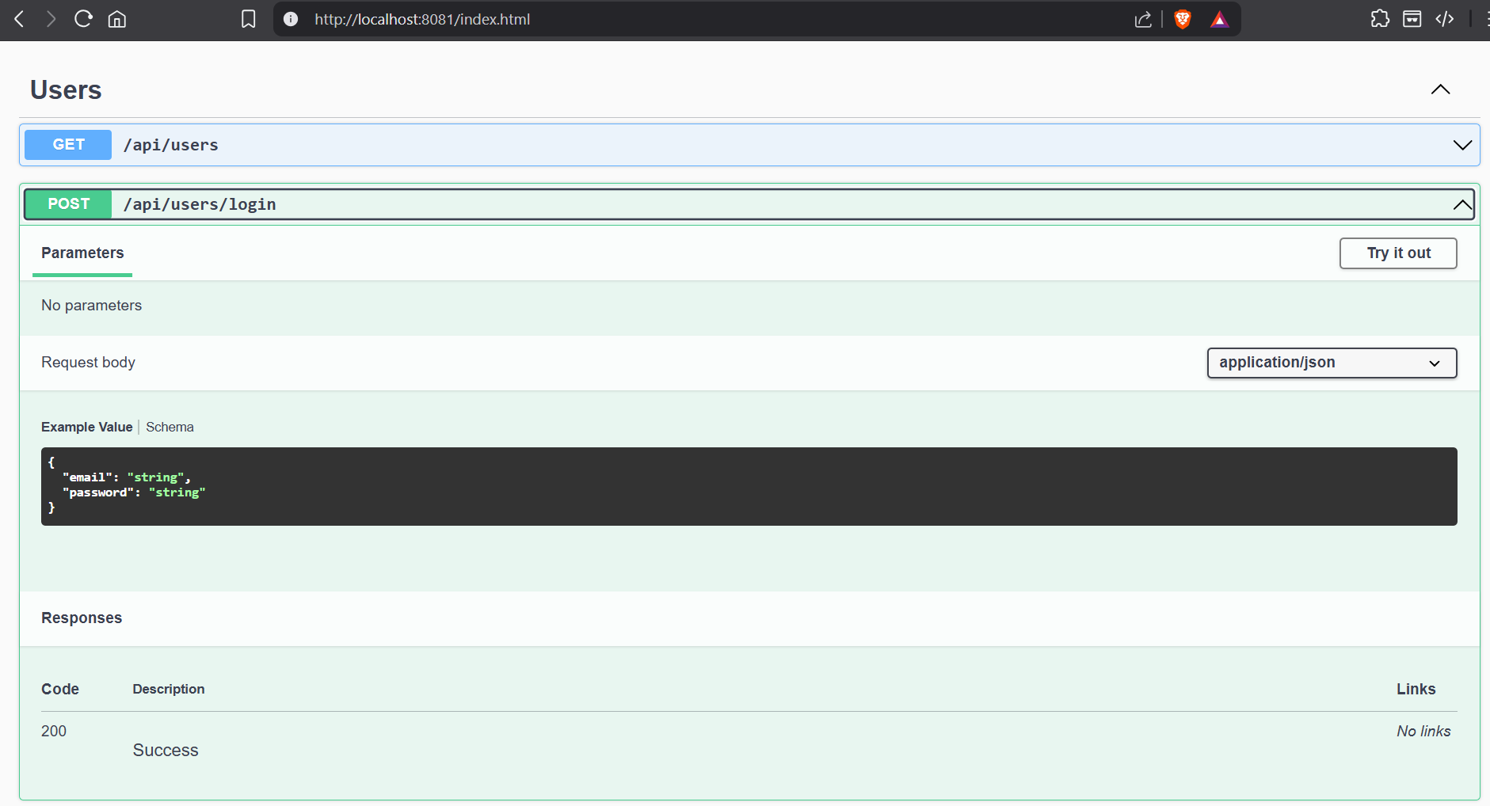

6.5 Product Service — Swagger UI

6.6 Product Listing (GET /api/products)

6.7 Order Service — Place Order

6.8 Cart Service — Add to Cart

6.9 API Gateway Routing

7. Testing — Test Reports
ShopEZ uses xUnit as the test runner and Moq for mock-based isolation. All tests are located in the /tests directory, with a dedicated test project per microservice. Tests cover service-layer business logic without touching a real database.

7.1 Test Summary
Service | Test File | Test Count | Coverage Focus
UserService | UserServiceTests.cs | 9 tests | Register, Login, validation
ProductService | ProductServiceTests.cs | 8 tests | CRUD, search, pagination
OrderService | OrderServiceTests.cs | 8 tests | Place order, history, validation
CartService | CartServiceTests.cs | 7 tests | Add, remove, clear, fetch

7.2 Test Execution
Tests are run using the dotnet test CLI:
cd tests/UserService.Tests && dotnet test

7.3 Unit Test Results
[ Screenshot Placeholder: Terminal output — dotnet test results showing all tests Passed for all 4 services ]

7.4 Sample Test Cases — UserService
Test Method | Scenario | Expected Result | Status
Register_ValidData_ReturnsUserDTO | Valid name, email, password | Returns UserDTO with correct name | Pass
Register_EmptyName_ThrowsArgumentException | Empty name field | Throws ArgumentException | Pass
Register_DuplicateEmail_ThrowsInvalidOperationException | Email already exists in DB | Throws InvalidOperationException | Pass
Register_InvalidRole_DefaultsToCustomer | Role = 'SuperUser' (invalid) | Role defaults to 'Customer' | Pass
Login_ValidCredentials_ReturnsUserDTO | Correct email + password | Returns UserDTO with user name | Pass
Login_WrongPassword_ReturnsNull | Correct email, wrong password | Returns null | Pass
Login_EmptyEmail_ThrowsArgumentException | Empty email field | Throws ArgumentException | Pass
Login_NonExistentEmail_ReturnsNull | Email not in DB | Returns null | Pass

7.5 Testing Approach
- Arrange-Act-Assert (AAA) pattern used in all tests
- Moq creates fake IRepository implementations — no real SQL Server connection required
- Repository.Setup() defines expected behavior for each mock call
- Assert.ThrowsAsync<T>() verifies that business rule violations throw correct exception types
- Positive tests verify correct data transformation through the service layer

8. Deployment Guide

8.1 Prerequisites
- Docker Desktop installed — https://www.docker.com/products/docker-desktop
- Docker Desktop must be running before executing any commands
- Minimum 4GB RAM allocated to Docker (configured in Docker Desktop settings)
- Ports 8080–8084 and 1433 must be free on the host machine

8.2 Step-by-Step Deployment
Step 1 — Clone / Extract Project
Extract the ShopEZ project folder to your working directory. Open a terminal in the ShopEZ/ root folder (where docker-compose.yml is located).
Step 2 — Build and Start All Services
docker-compose up --build
First run takes 5–10 minutes (downloads base images, builds all Dockerfiles). Subsequent runs are faster as layers are cached.
Step 3 — Seed the Products Database
After all services are healthy, open a new terminal and run:
docker exec -it shopez-sqlserver /opt/mssql-tools/bin/sqlcmd -S localhost -U sa -P "ShopEZ@123!" -i /dev/stdin < sql/init.sql
Step 4 — Verify Services
Service | Swagger URL | Health Check
User Service | http://localhost:8081 | GET /api/users → 200 OK
Product Service | http://localhost:8082 | GET /api/products → 200 OK
Order Service | http://localhost:8083 | GET /api/orders → 200 OK
Cart Service | http://localhost:8084 | GET /api/cart/{id} → 200 OK
API Gateway | http://localhost:8080 | GET /gateway/products → 200 OK

Step 5 — Connect Angular Frontend
Start the Angular app with ng serve. It is pre-configured to call http://localhost:8080/gateway/* routes through the API Gateway. No additional configuration is needed.
Step 6 — Stop All Services
docker-compose down
To also remove the persisted SQL Server volume (resets all data):
docker-compose down -v

8.3 Docker Compose Architecture

8.4 Environment Variables
Variable | Value | Used By
SA_PASSWORD | ShopEZ@123! | SQL Server container
ACCEPT_EULA | Y | SQL Server container
ConnectionStrings__DefaultConnection | Server=sqlserver;Database=ShopEZ_*;... | All microservices

9. Conclusion
ShopEZ successfully demonstrates a production-style microservices backend built entirely on the .NET ecosystem. The project achieves its core objectives of modularity, database isolation, containerized deployment, clean layered architecture, and comprehensive unit testing.

Key outcomes of this project include:
- A fully functional 5-container Docker environment that launches with a single command
- Four independently deployable microservices, each with its own database and clean 4-layer architecture
- Mixed ORM strategy: EF Core for convenience in most services, Dapper for performance-critical product queries
- Ocelot API Gateway providing a stable, unified API surface to the Angular frontend
- 32 unit tests across all services, covering positive flows, validation errors, and edge cases using xUnit and Moq

The architecture choices made in ShopEZ directly address the limitations of monolithic systems — each domain can be modified, scaled, or redeployed without impacting others. The project provides a solid foundation for enterprise-scale e-commerce development.

10. Future Scope

10.1 Security Enhancements
- JWT-based authentication integrated at the API Gateway level using Ocelot's auth middleware
- Role-based authorization: Admin-only routes for product CRUD, Customer-only routes for orders
- Password hashing using BCrypt or Argon2 (currently stored as plain text for prototype purposes)
- HTTPS/TLS termination at the gateway

10.2 Real-Time & Messaging
- Apache Kafka integration for event-driven communication between microservices — e.g., OrderPlaced event triggers inventory decrement in Product Service
- SignalR for real-time order status notifications to the frontend
- RabbitMQ as a lighter alternative to Kafka for pub/sub messaging

10.3 Observability
- Centralized logging with Serilog + Elasticsearch + Kibana (ELK stack)
- Distributed tracing using OpenTelemetry + Jaeger — trace a request across all microservices
- Health check endpoints with /health routes on each service, monitored by Docker or Kubernetes

10.4 Infrastructure Upgrades
- Kubernetes (K8s) deployment with Helm charts for auto-scaling and self-healing
- Separate Read/Write replicas per service database for high-read traffic scenarios
- Redis caching layer for product listings and cart data to reduce SQL Server load
- CI/CD pipeline using GitHub Actions — automated build, test, and push to Docker Hub

10.5 Feature Additions
- Payment gateway integration (Razorpay / Stripe) in a dedicated Payment Microservice
- Product recommendation engine using collaborative filtering
- Admin dashboard for inventory management, order tracking, and sales analytics
- Multi-image support per product with file upload to Azure Blob Storage or S3

